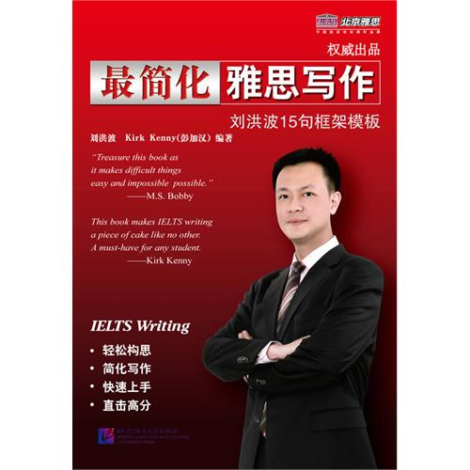
Best to simplify the IELTS writing (Kirk Kenny)
Introduction
The most prominent feature of the book is the writing combined with the author for many years to study the simplest and most easy to operate, mentioned IELTS Writing IELTS Writing for the mainland candidates. The perspective of the book from the mainland students to learn from the students' learning process a logical order to explain, to help the reader to first solve the problem of what to write ", then the vocabulary and grammar, in accordance with the different levels of students, given the different levels words, phrases, suitable for a targeted review.
A core part of the book is the sentence pattern of the 15 long-term R & D and demonstration, they are fully born out of the official score more than 7 points, the rigid structure of the sentence freedom; Its purpose is to regulate the article logic to simplify the thinking and writing difficulty . Has been of the majority of students in writing classes: simple, effective, and high scores.
Directory are knowledge of the first chapter of preparatory
1 IELTS content
2 IELTS process
3 IELTS writing steps
(4) other prior knowledge
Chapter II, who is writing the Chinese candidates a low score is responsible?
One of the most popular teaching error
2 kinds of questions misclassification
3 recite invalid synonym group
Too much emphasis on the value of the Cambridge IELTS of at least 250 words
5 out of nothing the difference between the test sites
Task 2 writing the first chapter neglected gold - the official score

